## Storing external libraries

### Introduction

The Scapi project uses external libraries that may be written in other languages such as C and C++. These libraries can be supplied in lib files that later on will be integrated into JNI dll's that we write.

In general in order to use scapi we do not need the lib files of the external libraries (such as Crypto++ and NTL) at all. The lib files are integrated into the dll's of the jni that we write at compile (link) time.  
All we need are the dll's files in order for the various JNI's to work.  
Since the lib is integrated in the linking phase the created obj files must be from the same compiler and thus so does the lib file.

It is true that after one compiles the lib file the others will most probably will not have to do so since we all use the same compiler. However it is still important to maintain the lib projects of the external libraries for the following reasons.

1. Creating the initial lib project can be time consuming depending on the used libraries. Thus, having a backup of the projects in the svn is wise.
2. If the used library is updated, the lib project should be updated and compiled again.
3. If we wish to upgrade our native language compiler, again we will have to compile the lib again (also maybe to make some modifications to the solution itself)
4. If the lib file was corrupted for some reason, a new compilation of the project will be necessary.
5. Every team member that needs to add some functionality to the jni dll's will need the external library project since he/she will have to include files from the lib project. It is essential that all the scapi project team members will have the same version of the external libraries to refer to. The version in the svn will be the version to work with.

### Svn path

The current project path is the following:

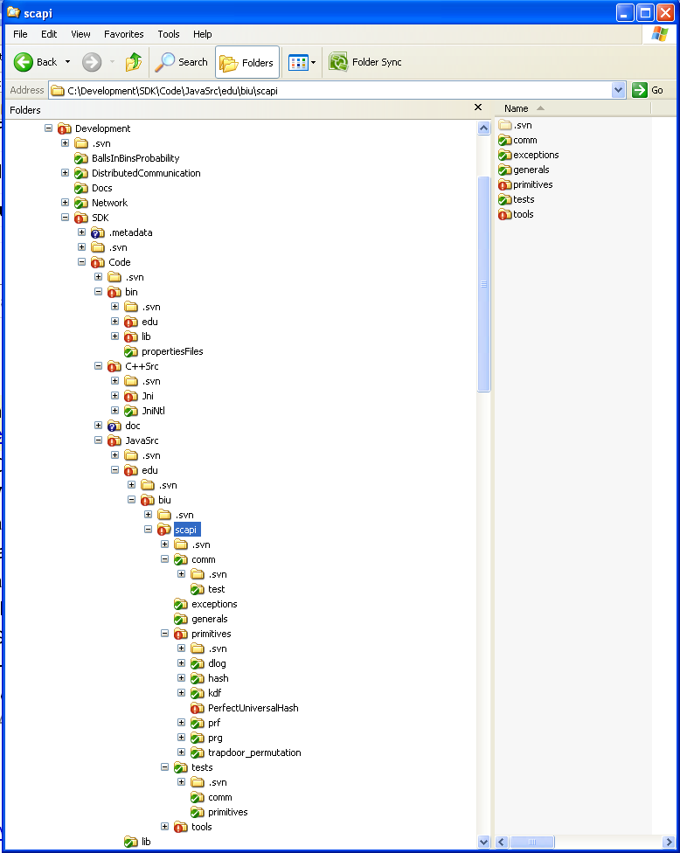

#### External libraries

The path for the external libraries solutions will be:

Development 🡪 External Libraries 🡪NTL

Development 🡪 External Libraries 🡪Crypto++

Development 🡪 External Libraries 🡪Miracle

The external libraries are separated from the SCAPI project. They will not be under the folder code.

#### Compiled jni dll files

The compiled dll's to use will be under C:\Development\SDK\Code\JavaSrc\lib since the java code refers to that location to load the dll's.

#### Jni dll projects

The jni projects that we write will be under C:\Development\SDK\Code\C++Src

The dll for the jni ntl for example will be under C:\Development\SDK\Code\C++Src\JniNtl.